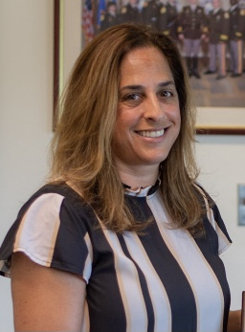
Hi, my name is RoMi Dunning (pronounced (Row-Me). I wanted to take a moment to introduce myself. I will be starting this school year off in the new School Climate Safety position. I will divide my time between North Smyrna Elementary School, Smyrna Elementary School and John Bassett Moore.
My plan is to be at each particular school at the beginning of the day and leave after dismissal. Some of my responsibilities will be to support the teaching staff, help out during recess / lunch and monitor safety plans for the school.
I am a mom of three all of which attended North, JBM and Smyrna Middle School. I am fortunate to have met many teachers and staff throughout those years that I now call friends.
My oldest Grace is living on her own, going to school and working. We are now the proud grandparents of Luke, sometimes known as Pukie…for obvious reasons.
Isabella is attending her 2nd year at Norwich University, Vermont which a military school. The Army has kindly offered to pay for her education where Bella has graciously committed to them for 8 years after graduation.
My youngest is attending his freshman year at First State Military Academy-Go Bulldogs however I will always be a Smyrna Eagle at heart. As a family we have always had great experiences at all of the schools we attended and truly love the district. My husband Rich was born and raised in the area and graduated from Smyrna H.S.
I’m a native New York’A’ and moved to Delaware after attending West Chester University. Shortly after graduation I got a job in the state and never left. I retired a month ago after 29 years as a police officer with New Castle County Police Department. I spent time in the foot patrol unit, as the DARE officer and School Resource Officer. I was also able to work in our Community Services Unit where I was fortunate to educate the public on the heroin epidemic. I was lucky to meet families from diverse backgrounds where we created long working and personal relationships that I cherish to this day. I have always based my career on treating others with kindness and respect.
I am looking forward to this new journey working in Smyrna School District and learning from all of you. Please feel free to reach out if there is anything I can help with.
-RoMi
Romi.dunning@smyrna.k12.de.us,
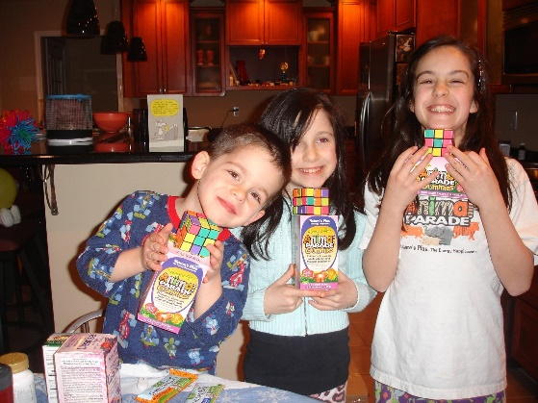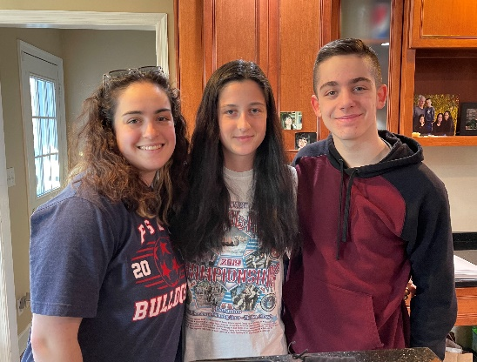
Richie, Bella and Grace - Many Moons ago Grace, Bella and Richie – Recently

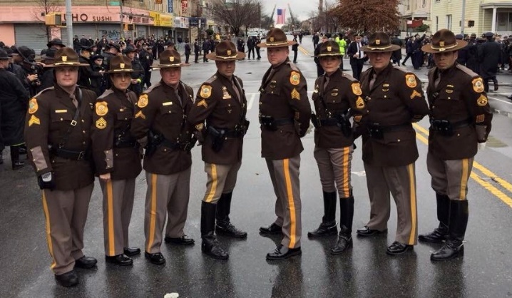. 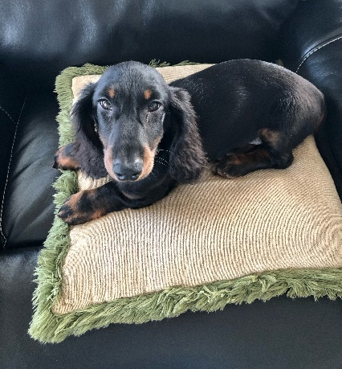
Together with brothers and sister from my Luke...the grand dog
Blue Family
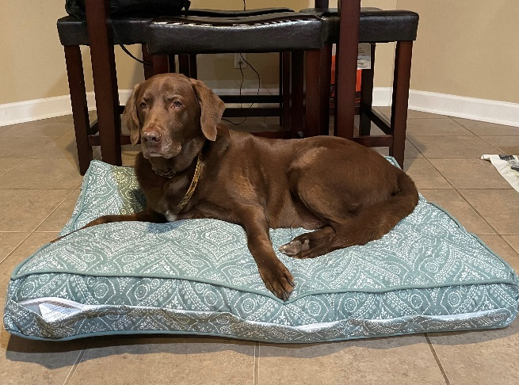
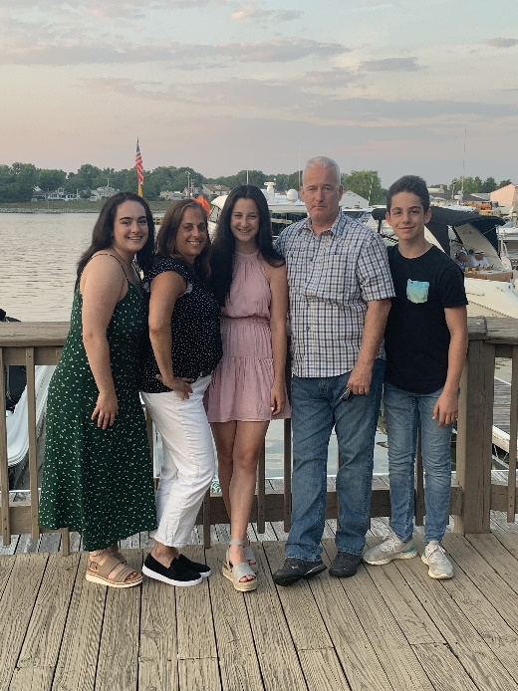 The best dog - my old man Kramer

